Evaluating CA2 Hippocampal Neurons as Novel Targets in Epilepsy
SPECIFIC AIMS
Temporal lobe epilepsy (TLE) is one of the most common types of seizure disorder. Although several treatments are available, many patients are medically intractable, or suffer debilitating side effects of antiepileptic drugs. Surgical intervention may not be an option or only be successful for a short time. Novel treatments based on the underlying etiology promise a better approach. One common finding in both TLE patients and animal models of TLE is that significant hippocampal cell death occurs, in a pattern of neuropathology termed mesial temporal sclerosis (MTS). Remarkably, this cell death appears to largely spare pyramidal neurons (PNs) in hippocampal area CA2 and dentate gyrus granule cells. Moreover CA2 neurons in hippocampal tissue from patients with epilepsy show enhanced excitability. Although these results suggest that CA2 may play an important role in epilepsy, there have been no direct experimental tests of this hypothesis.
We recently found that CA2 PNs are strongly driven by direct input from layer II neurons of entorhinal cortex and that the CA2 neurons make strong excitatory synapses onto their downstream CA1 pyramidal neuron targets. This allows CA2 to serve as the nexus of a powerful disynaptic circuit directly linking entorhinal cortex input to hippocampal CA1 output (EC→CA2→CA1). Recent studies from our laboratory and others show that CA2 also projects to the contralateral CA2 region and may project directly back to EC. These results support the idea that that CA2 may serve as a focus for seizure generation and ipsilateral and contralateral seizure propagation to cortical structures. Here we will directly test the role of CA2 in both in vitro seizure-like activity and in vivo seizure generation in a mouse model of epilepsy.
Until recently, technical limitations have prevented the possibility of specifically silencing CA2 neurons, due largely to the small size of CA2 and its location interspersed between CA1 and CA3. We recently developed a new transgenic mouse line in which Cre recombinase is expressed relatively selectively in CA2 PNs in the hippocampus of adult mice (Amigo2-Cre mouse). Using injections of Cre-dependent AAV vectors into the CA2 region, we are able to achieve relatively selective protein expression in CA2 PNs, allowing us to map CA2 inputs and outputs and control CA2 activity through either optogenetic or pharmacogenetic tools. Here we propose to use the Amigo2-Cre mouse to begin to explore the role of the CA2 region in acute and chronic temporal lobe seizures both in vitro and in vivo, in two specific aims.
Validation of CA2 as a potential contributor to epilepsy could provide an important novel target for pharmacological or surgical interventions in the treatment of seizures resistant to more standard therapies. Indeed, CA2 PNs express a number of receptors and channels at very high levels relative to other areas of the brain (e.g. the adenosine receptor, vasopressin receptor, TREK K+ channel), which may represent novel drug targets for epilepsy treatment.
We will employ a widely used rodent model of TLE, in which pilocarpine (PILO)-induced status epilepticus (SE) results in the development of chronic seizures. Epileptogenesis in this model is accompanied by a significant pattern of hippocampal cell death that spares CA2 PNs, reproducing the pathology seen in patients with mesial temporal sclerosis. The role of CA2 PNs in acute and chronic seizures will be assessed through the following specific aims:

- Do hippocampal CA2 PNs play a role in generation of seizure-like activity in acute hippocampal slices in vitro? To address this question, we will induce acute seizure-like activity pharmacologically in hippocampal slices from normal Amigo2-Cre mice. We will record seizure-like burst activity induced by this procedure in CA1 and CA2 PNs, and examine the effect of selective optogenetic silencing of CA2 on seizure activity. Next, we will obtain acute hippocampal slices from mice with a pilocarpine model (PILO) of temporal lobe epilepsy with mesial temporal sclerosis. We will examine spontaneous seizure activity in hippocampal slices from PILO mice displaying chronic seizures. Again we will examine seizure like activity in CA2 and CA1 PNs in acute slices (in normal extracellular solution) and determine the effect of optogenetic silencing of CA2. Based on our hypothesis and preliminary results, we predict that CA2 silencing will greatly reduce seizure-like activity in CA1.
- Do CA2 PNs regulate chronic seizure activity in vivo in a mouse model of TLE? In this aim we will examine the effect of silencing CA2 on chronic seizure activity in the PILO model of TLE in Amigo2-Cre mice. We will silence CA2 acutely after seizures develop using a pharmacogenetic approach and determine whether this intervention alters seizure frequency, duration or severity. Alternatively we will express tetanus toxin to chronically inactivate CA2 output, and determine effects on seizure activity.

The experiments of these two aims will provide us with an unprecedented opportunity to directly examine the role of CA2 in a mouse model of human TLE with mesial temporal sclerosis.
A. Significance
Temporal lobe epilepsy (TLE) is a leading form of treatment-resistant epilepsy (Semah et al., 1998). The hippocampus is one of the temporal lobe regions strongly implicated in TLE. Almost all studies concerning hippocampal function, including its involvement in TLE, have focused on the classic hippocampal trisynaptic pathway, where entorhinal cortical (EC) projection cells excite dentate gyrus (DG) granule cells, which excite hippocampal CA3 pyramidal neurons (PNs), which then excite CA1 PNs, the major hippocampal output. This is because the trisynaptic path provides strong excitatory drive to the CA1 output region. However, there is increasing evidence indicating that seizure propagation may occur through other pathways (Ang et al., 2006).
Several lines of evidence suggest that the hippocampal CA2 region, which has received little attention following its original description by Lorente de No in 1934 (Lorente de No, 1934), may play a critical role in TLE. Thus CA2 PNs (along with DG granule cells) are one of the few hippocampal areas that survive in intractable TLE (Leranth and Ribak, 1991; Scharfman and Pedley, 2006), in contrast to the neurodegeneration of CA1 and CA3 that characterizes the hippocampal pathology in mesial temporal sclerosis (MTS). As the DG granule cells typically lose most of their normal targets in MTS (hilar neurons and CA3 neurons), it has been unclear how the trisynaptic circuit would be able to efficiently initiate or propagate seizures. However, recent results suggest that DG also projects to CA2, in addition to CA3 (Kohara et al., 2014). Although in normal brain tissue the connection from DG to CA2 is relatively weak, there is evidence for the reorganization of mossy fibers to CA2 in intractable TLE (Mathern et al., 2002). Moreover, studies of resected tissue from hippocampus of patients with TLE show that CA2 could be a generator of seizures, or an amplification mechanism (Wittner et al., 2009); Williamson and Spencer, 1994). Finally, results in hippocampal slices (add refs here), including our recent preliminary findings, suggest that CA2 can act as a focus of epileptiform-activity in in vitro models.
Even though the CA2 region contains only 10% of PNs in CA1 or CA3, our studies and those of others suggest that this region acts as an important conduit of information flow through the hippocampal circuit and plays an important behavioral role in the normal brain. Thus, CA2 PNs receive strong direct excitatory input on their distal dendrites from entorhinal cortex layer II neurons, and, in turn, make unusually strong synapses with their CA1 PN downstream targets (Chevaleyre and Siegelbaum, 2010; Hitti and Siegelbaum, 2014; Kohara et al., 2014; Sun et al., 2014). As a result, CA2 mediates a powerful disynaptic circuit directly linking EC input to CA1 output (EC→CA2→CA1). In addition, CA2 also receives input from CA3 Schaffer collaterals, although these inputs only weakly excite CA2 because of strong feed-forward inhibition mediated by a high density of GABAergic parvalbumin positive (PV+) basket cells in CA2. Although it is not yet clear whether CA2 pyramidal cells also form strong recurrent connections, they do form excitatory synapses with the contralateral CA2 region. Furthermore, CA2 pyramidal cells may send direct projections back to superficial layers of EC (Rowland et al., 2013), raising the possibility of a reciprocal excitatory EC←→CA2 loop.
In this proposal we plan to explore the hypothesis that CA2 PNs play an active role in seizure generation. Until now it has been impossible to explore this hypothesis because of the lack of specific tools to evaluate CA2, as the small size of this region, wedged between CA1 and CA3, makes CA2 impossible to selectively lesion or pharmacologically silence. Here we take a novel genetic approach using a recently developed BAC transgenic mouse line, the Amigo2-Cre mouse, that expresses Cre recombinase in a manner largely restricted to CA2 PNs in the adult mouse brain (Hitti and Siegelbaum, 2014). Through targeted injections of Cre-dependent virus into the CA2 region in the hippocampus of adult mice, we have selectively expressed proteins in this region to define CA2 circuitry and manipulate CA2 function. By silencing CA2 PN output through selective expression of tetanus toxin (TeTx) using injections of Cre-dependent AAV vectors (AAV^{Cre}) targeted to CA2, we demonstrated that CA2 plays a fairly specific role in social memory, the ability of an animal to recognize another member of its species. This finding is of particular interest given the findings that individuals with epilepsy suffer from altered social interactions, which is also seen in rodent models of epilepsy models (need refs). Here we propose to conduct pioneering experiments to test the importance of the CA2 region in TLE by selectively silencing this region with Cre-dependent viral vectors in both in vitro hippocampal slices (Aim 1) and in vivo using a mouse model of TLE where CA2 and the DG are the primary surviving areas, like MTS (Aim 2).
Defining the role of CA2 at different stages of epilepsy development will have significant clinical implications as there are a number of receptors and channels that show relatively selective expression in CA2, and thus may prove to be novel useful therapeutic targets. Therefore, the experiments proposed here may lead to “CA2-specific” pharmacotherapy. Furthermore, this application has the potential to greatly impact the way hippocampal function is currently conceptualized in TLE. Finally, this project will have impact because it explores a technical approach that could be used for other epilepsy research studies where selective activation or suppression of activity in a small region of the brain is hypothesized to be critical for seizure control.

B. Innovation
To date there have been few if any studies directly examining the importance of CA2 in TLE and seizure generation. Here we will use our recently developed Amigo2-Cre mouse line to enable us to selectively silence CA2 and directly explore the consequences on seizure activity in both in vitro slice models and in an in vivo chronic TLE mouse model. These results would lead to a paradigm-shift about TLE circuitry, which has focused on the trisynaptic path and connections from DG to CA3 to CA1, with little consideration for a role of CA2. We emphasize that prior to the development of such a CA2-specific genetic-based targeting approach it has been technically unfeasible to examine the role of CA2 as traditional pharmacologic or surgical lesions do not afford the requisite regional selectivity.

C. The Approach:
Rationale and central hypotheses:
Regardless of the ways CA2 PNs could influence seizure generation in the normal brain the preservation of CA2 PNs and their enhanced excitability in intractable TLE in humans (Wittner et al., 2009) suggests their critical role in chronic spontaneous recurrent seizures. We hypothesize that seizures may cease when the hippocampus is surgically removed because surgery ablates a complex aberrant circuitry that remains between the EC, DG and CA2. Indeed our preliminary results indicate that silencing CA2 can reduce epileptiform activity in an in vitro hippocampal slice model of seizures. This leads to the central hypothesis of our proposal, that altered CA2 function, perhaps in conjunction with altered function in neurons within the EC and surviving neurons in the DG, creates a circuit with a permanently low seizure threshold that may serve as a focus to generate spontaneous seizures.

General experimental plan:
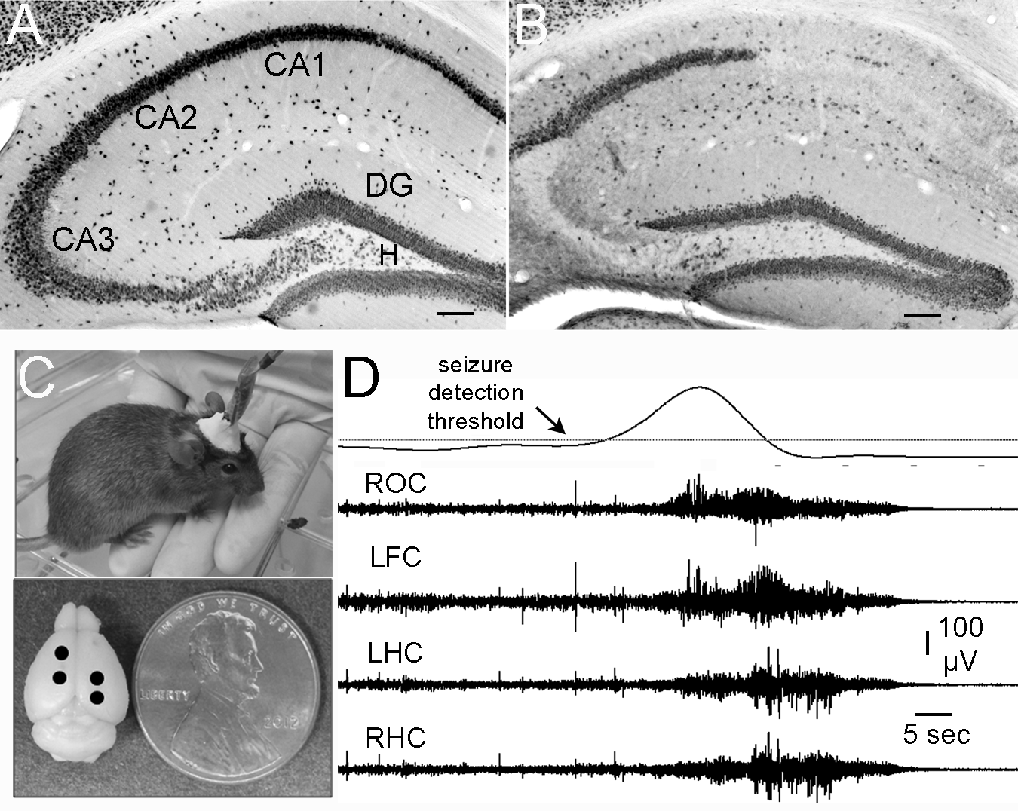
The effects of silencing CA2 with Cre-dependent viral vectors will be examined first at the in vitro level in acute hippocampal slices. In Aim 1a we will examine effects of CA2 silencing on pharmacologically-induced seizure-like activity in acute slices from Amigo2-Cre mice. In Aim 1b we examine the role of CA2 in seizure-like activity in slices from a mouse model of TLE with MTS-like neuropathology and chronic limbic seizures. In Aim 2 we test the effect of in vivo CA2 silencing on chronic seizures in the TLE mouse model.
Fig. 1. Hippocampal (HC) NeuN staining in mice injected with saline (no seizures) (A) or PILO to induce SE (B). Mice were perfused 3 months after injections. Note neuronal loss similar to MTS in (B), Bar, 100 μm. C. Top: Mouse implanted with electrodes. Bottom: Sites of subdural screw electrodes over right occipital cortex (ROC), left frontal cortex (LFC) and bipolar electrodes in left and right dorsal HC. D. Spontaneous seizure detected using total EEG power, top, and the 4 electrode traces (Sirenia software, Pinnacle Technologies).

We will use a model of TLE with MTS induced by an initial episode of status epilepticus (SE) in response to pilocarpine (PILO). We have carefully established and validated a protocol suitable for C57BL/6 mice (the background strain of the Amigo2-Cre line), which normally have a high mortality in response to PILO that limits their use (ref Mckhann et al 2003, Schawecker 2012). We will cross Amigo2-Cre mice (C57BL/6J substrain) with wild-type mice from Harlan laboratories (C57BL/6 substrain) and perform experiments on adult (10-12 weeks old) F1 hybrids. Mice are injected with atropine methylsulfate (1 mg/kg, i.p.) to prevent peripheral side effects of PILO, followed 30 min later by PILO (280 mg/kg, i.p.) to induce SE, and finally by diazepam (5 mg/kg i.p.) 2 hrs after the onset of SE to decrease seizure severity. Onset of SE corresponds to the first observed stage 4-5 seizure, if the animal does not resume normal behavior within 5 min. Following SE, mice are placed in a heated (30 ºC) and humidified chamber (Thermocare, Inc.), where they remain for 48 hrs with food and water ad libitum. The survival rate of this protocol in our hands is >80% (16 out of 19 animals). Within 3 days of SE, the majority of surviving mice exhibit a loss of CA1 and CA3 neurons, with a sparing of DG and CA2 neurons (Fig. 1A,B; see also Winawer et al., 2007), similar to the pathology in human MTS. Six to eight weeks after SE, mice with MTS develop spontaneous convulsive seizures (2.6 + 0.4 seizures/day, n=12; Fig. 1D). The minority of mice (that do not exhibit MTS) exhibit rare chronic seizures (1-2 per week; data not shown). In all SE experiments we will start with approximately 15 animals per group, which should give us at least 10 surviving animals per group following SE and surgery for chronic EEG electrode implants (Fig. 1C,D), a number that has sufficient power for statistical comparisons between experimental and control groups. Statistical significance will be assessed by two-tailed unpaired Student’s t-tests-way ANOVA, or 2-way repeated measures ANOVA where appropriate. Significant main effects or interactions will be followed up with Holm-Sidak’s correction for multiple comparisons. Results are considered significant when P < 0.05. α will be set to 0.05 for multiple comparisons.

Specific Aim 1. Does CA2 play a role in controlling seizure-like activity in hippocampal slices?
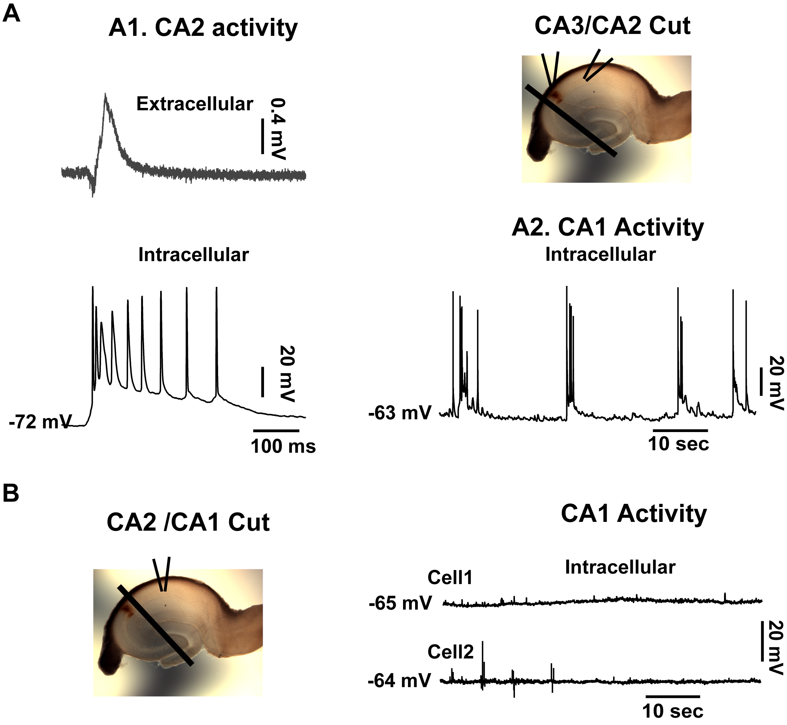
Aim 1a. Does CA2 promote seizures induced pharmacologically in acute hippocampal slices from normal mice? In preliminary results we addressed this question by measuring seizure-like bursting activity in a hippocampal slice in response to a 0 Mg²⁺, 0.1 mM 4-aminopyridine (4-AP) external solution (Fig. 2). Within 45 min, discharges were observed in field and intracellular recordings from CA2 and CA1 cell layers, with burst amplitude greater in CA2 than CA1. Importantly, bursting was not prevented by surgical removal of CA3 (using a cut near the border of CA2 and CA3). In contrast, when we cut the slice between CA1 and CA2, bursting activity in CA1 was abolished but not CA2. These experiments suggest a role of CA2 in burst generation, but are not definitive because the borders between subregions are imprecise and as a result, some CA3 PNs may have remained after transecting the CA2 border with CA3.
Fig. 2. Bursting in CA2 and CA1 occurs in absence of CA3 (A) but requires CA2 (B).
Fig.1. Bursting in CA1 and CA2 without CA3 (A) or without CA2+CA3 (B).
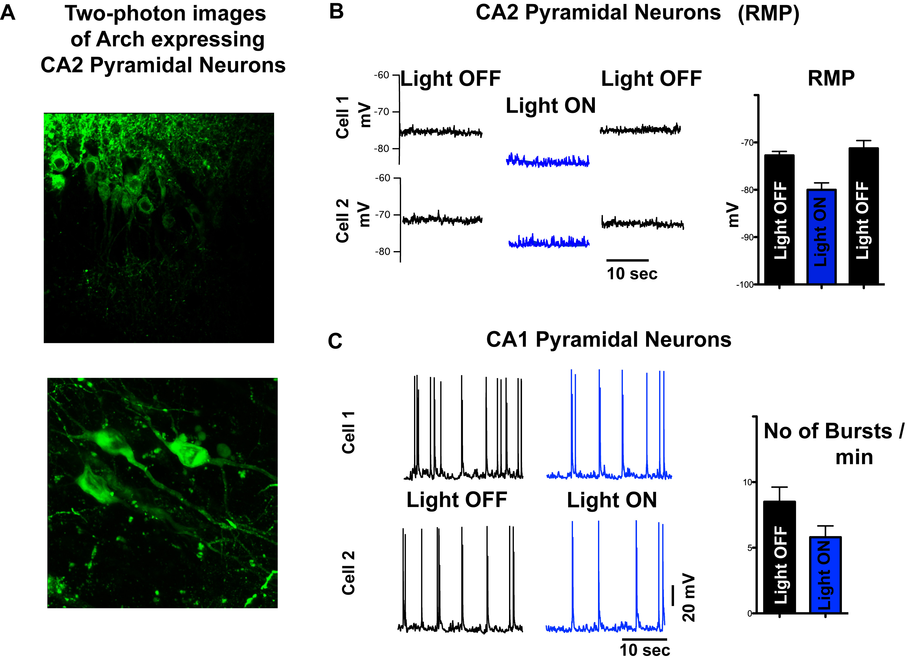
To definitively address the role of CA2 PNs in this type of induced epileptiform activity, we will use optogenetics to silence a genetically defined population of Amigo2-Cre positive CA2 PNs. We will express selectively in CA2 PNs the light-activated proton pump Archaerhodospin (Arch), which silences neurons by hyperpolarization. An AAV^{Cre} vector-expressing Arch and green fluorescent protein (AAV9-CAG-Flex-Arch-GFP) is injected stereotaxically into the CA2 region of anesthetized Amigo2-Cre mice. After 2-4 weeks to allow for sufficient Arch expression, we will prepare hippocampal slices and record activity from CA1 and CA2 in the 0 mM Mg²⁺/0.1 mM 4-AP solution described above. Once epileptiform bursting develops, the slices will be exposed to 565 nm light for 10-20 s, times that will activate Arch and silence CA2 (Fig. 3). We will determine the effects of light on epileptiform burst frequency and burst duration. Control experiments will be performed using exposure of slices to the identical solution and light; however the slices will be obtained from mice injected with an AAV^{Cre} to express GFP in CA2 PNs, instead of Arch and GFP. Preliminary results show that light exposure to slices in which CA2 PNs express Arch induces a large hyperpolarization of the CA2 neuron membrane and, importantly, leads to a 30% decrease in frequency of epileptiform bursts recorded in CA1 in the 0 Mg²⁺/4-AP solution, with no change in burst duration (Fig. 3). We believe this is a lower limit for the contribution of CA2 PNs to seizure activity because of incomplete infection of CA2 PNs in these experiments. Future experiments will optimize expression efficiency of Arch using a higher volume of high-titer virus and/or allowing for a longer time for viral expression prior to our slice recordings. We will record from CA2 PNs during exposure to the 0 Mg²⁺/4-AP solution to verify that the photostimulus is capable of silencing the majority of CA2 neurons during bursting activity. After experiments, slices will be fixed and stained to identify expression levels using GFP immunofluorescence as a reflection of Arch expression. We predict that ability to influence burst frequency and duration will significantly correlate with expression.
Figure 3. Silencing CA2 PNs optogenetically with Arch reduces burst firing in CA1. A, Arch-GFP. B, Light hyperpolarizes CA2 PNs expressing Arch. C, Photoactivation of Arch in CA2 PNs reduces bursting in CA1 PNs.
It is possible that photoactivation of Arch will not fully suppress CA2 firing because of the strong excitatory drive during bursting. If so we will silence CA2 PNs by expressing TeTx, which effectively blocks transmitter release from CA2 PNs, while the neurons remain otherwise normal (Hitti and Siegelbaum, 2014). As TeTx permanently silences transmitter output, we will compare burst activity in control (slices expressing GFP in CA2 PNs) versus experimental (TeTx-silenced CA2 PNs) slices. We will apply the 0 Mg²⁺/4-AP solution to both sets of slices and compare burst frequency and burst duration to determine how silencing CA2 PN output alters epileptiform activity. To gauge the effectiveness of CA2 silencing, we will coexpress the light-activated channel, ChR2, together with TeTx (experimental) or GFP (control), in CA2 PNs. We will record the magnitude of the light-evoked EPSP in CA1 PNs and confirm that TeTx expression fully blocks the EPSP (see Hitti, 2014).
Based on our preliminary data, we are confident that these results will confirm that CA2 silencing leads to at least a 30% reduction in burst firing, and may produce a substantially larger inhibition. We also predict that burst discharges in CA3 will be relatively unaffected as they are “upstream" of CA2.
Aim 1b. Does CA2 support spontaneous seizure activity in acute hippocampal slices obtained from a mouse model of TLE? Although Aim 1a is likely to confirm the importance of CA2 in generating seizure-like activity, these experiments rely on a pharmacological model of epileptiform activity, and thus their relevance to chronic spontaneous seizures is open to question. Here we address this limitation by examining spontaneous epileptiform bursts in acute slices from PILO-treated mice after they develop chronic epilepsy (Fig. 1). Epileptiform burst-like activity occurs in acute hippocampal slices from PILO-treated epileptic rats (Scharfman et al., 2000; McCloskey et al.,2011), and we have recently found that hippocampal slices from PILO-treated epileptic mice show spontaneous burst activity (at 0.05 to 0.25 Hz; Scharfman, unpublished).
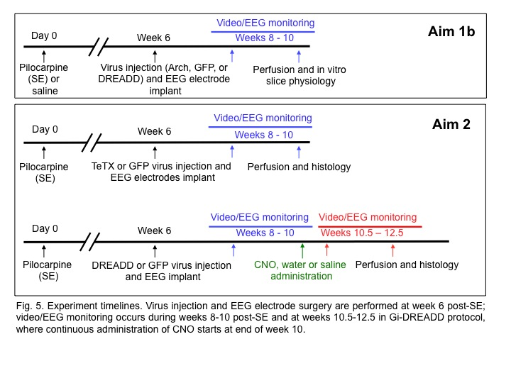
We will follow the protocol outlined above to obtain PILO-treated (or saline-injected control) mice expressing Arch or GFP in CA2. As shown in the timeline of Fig. 4, six weeks following SE induction, a time when chronic epilepsy has developed, mice will be implanted with electrodes for EEG recordings (one frontal and one occipital subdural electrode; bilateraldepth electrodes in dorsal hippocampuse; see Iyengar et al., 2014; Fig. 1C). At the same time the CA2 region will be injected with AAV^{Cre} to express Arch or GFP. We will use chronic video-EEG with computer-based automated analysis to monitor the development of spontaneous seizures (Pinnacle Systems, for detailed methods see Iyengar et al., 2014; Fig. 1D). We will wait two weeks for mice to recover from surgery and record video-EEG continuously for 2 weeks, 8–10 weeks after SE (Fig. 4). Seizure frequency, duration and severity (using the Racine scale) will be analyzed blinded. PILO-treated mice that have ≥1 seizure per day will subsequently be sacrificed and hippocampal slices prepared for electrophysiology.
Fig. 4. Experiment timelines. Virus injection and EEG electrode surgery are performed at week 6 post-SE; video/EEG monitoring occurs weeks 8-10 post-SE and weeks 10.5-12.5 with Gi-DREADD, where continuous administration of CNO starts at end of week 10.

We will use extracellular field recordings from the CA2 and CA1 regions in acute slices from experimental (PILO) and saline groups in normal ACSF to monitor evoked and spontaneous epileptiform bursts. We expect to observe bursts only in the PILO-treated group with chronic seizures. As cell loss can be extensive in CA1 (Fig. 1), bursts may be small by extracellular recording (Scharfman et al., 2000) a problem that can be circumvented by intracellularly in surviving neurons (see Scharfman et al., 2000). We will deliver a 10-20s-long pulse of 565 nm light to: 1. The Arch-expressing PILO-treated group to silence CA2, and 2. The GFP-expressing PILO-treated group to control for off-target effects of light. Changes in frequency, burst morphology (using the coastline burst index; Traynelis and Dingledine, 1988; Mccloskey et al., 2005) or duration of epileptiform bursts will be measured. If CA2 is indeed important for epileptiform activity, light delivery will reduce burst discharges in slices from PILO-treated mice in the group expressing Arch but not GFP. We will confirm the efficacy of light stimulation in silencing CA2 PNs using whole cell recordings.
If slices from the PILO-treated group do not show spontaneous bursts, we will increase the K+ concentration slightly (up to 10 mM) from its normal value of 2.5 mM, which should induce epileptiform activity in slices from TLE model animals relative to saline controls (as found in rats, Mcloskey et al 2011).
If we fail to silence CA2 with Arch, we will use an alternative, pharmacogenetic approach. with an engineered muscarinic receptor, hM4Di, termed Gi-DREADD, which is stimulated by its cognate synthetic ligand clozapine-N-oxide (CNO) (Zhu and Roth, 2014). CNO stimulation of Gi-DREADD hyperpolarizes neurons by activating endogenous Gi and GIRK channels, which are abundantly expressed by CA2 PNs (Ponce et al, 1996). We will first gauge the efficacy and specificity of this approach using injections of AAV^{Cre} to express Gi-DREADD versus GFP in CA2 of normal Amigo2-Cre mice. We will obtain hippocampal slices 4 weeks after viral injection and examine effects of CNO on CA2 resting potential and action potential firing in response to current injection. We expect that CNO will selectively silence CA2 neurons expressing Gi-DREADD but have no effect on CA2 neurons expressing GFP (based on lack of reported off-target effects of CNO). If we confirm the utility of this approach, we will determine the efficacy of CNO in reducing spontaneous seizure activity in slices from PILO-treated mice expressing Gi-DREADD (versus controls expressing GFP), using the protocol of the above Arch experiments.
Anticipated Outcomes: The experiments of this aim should confirm and extend our preliminary results that CA2 is sufficient and necessary for full expression of epileptiform burst activity induced pharmacologically in acute hippocampal slices. The experiments will also enable us to test the role of CA2 in spontaneous epileptiform activity generated in slices from PILO epilepsy model mice. Such experiments will provide strong initial support for the role of CA2 in epilepsy. The ability to measure seizure-like activity in acute slices from epileptic animals will open up the possibility of carrying out a detailed analysis of potential changes in CA2 intrinsic properties or extrinsic circuitry that contribute to this abnormal activity in a future study. Irrespective of the results of Aim 1 on the role of CA2 in epileptiform activity in isolated slices, it will be critical to perform the experiments of Aim 2 examining the role of CA2 in chronic seizures in vivo, where a range of factors could influence how CA2 contributes to seizure generation.

Specific Aim 2. Does CA2 play a role in controlling spontaneous seizures after development of epilepsy following SE?
The experiments of Aim 1 will determine the role of CA2 in seizure-like activity in vitro. Here we address the importance of CA2 for spontaneous seizures in vivo in the PILO model of TLE. Because chronic seizures occur only 1-3 times per day, we need to record effects of CA2 silencing on seizures for a 2 week period to obtain sufficient data. This precludes the use of Arch as prolonged light exposure may have deleterious effects. We will thus silence CA2 using CNO/Gi-DREADD as discussed above, assuming this approach is shown effective and specific in Aim 1b. Because CNO IP injections are effective for only a few hours, we will administer CNO chronically through the drinking water (e.g. Cassataro et al., 2014) or by an ALZET osmotic minipump where we have experience (Scharfman et al., 2002). Minipumps will be subcutaneous, much easier than prior work (Scharfman et al., 2002).
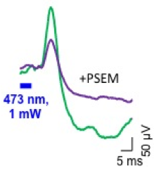
We will first determine the efficacy of this approach in silencing CA2 in vivo. We will co-express channelrhodopsin-2 (ChR2) with either Gi-DREADD or GFP using injections of two independent AAV^{Cre} vectors into CA2 of Amigo2-Cre mice. At the time of viral injections, mice will be implanted with EEG electrodes. Four weeks after surgery, we will measure local hippocampal field potentials (using the depth electrodes in hippocampus as described above) in response to pulses of 470 nm laser light. We will then inject animals IP with CNO and determine its efficacy in reducing the field response. We have used this approach (Fig. 5) to monitor the efficacy of pharmacogenetic-based CA2 silencing with PSEM/PSAM (Magnus et al., 2011) and do not anticipate problems (note: we cannot use PSEM here because of off-target effects). Next we will administer CNO chronically, either in the drinking water or by pump infusion, and will monitor light-evoked field responses during a 48 hr (longer if necessary) period of CNO administration to determine its efficacy and duration of action in reducing CA2 output in mice expressing Gi-DREADD vs GFP.
Fig. 5. Field potentials in SR of CA1 elicited by a 5 ms, 470 nm light pulse through fiber optic probe over CA1 in Amigo2-Cre mice expressing ChR2 + PSAM, before and after IP injection of PSEM.
If we confirm the efficacy and selectivity of this approach in normal mice, we will next examine the action of CNO on spontaneous seizure activity in PILO-treated Amigo2-Cre mice expressing Gi-DREADD vs GFP and implanted with EEG electrodes. We will record from mice expressing Gi-DREADD (divided into one experimental group that will receive CNO and one control group that will receive saline, 10 animals each), in addition to the control GFP group that will receive CNO (10 animals). Mice will be injected with virus and implanted with electrodes 6 weeks after SE. We will measure seizure frequency, duration, and severity during 2 weeks of continous video-EEG between weeks 8-10 after SE. CNO will then be continuously administered through the drinking water or subcutaneously with a mini pump and then seizure activity will be monitored for an additional two weeks during exposure to CNO. The control Gi-DREADD group will receive saline. EEGs will be analyzed by computer, with manual review used to confirm results on a regular basis . Seizure parameters will be compared among the groups and within animals (before and after CNO or saline) using ANOVA. In our experience seizure activity is relatively constant during weeks 8-12 after SE without additional experimental intervention.
If CNO/Gi-DREADD cannot reduce CA2 activity or has (off-target) effects in GFP-expressing mice, we will silence CA2 with TeTx using AAV^{Cre} injection in CA2 of Amigo2-Cre mice 6 weeks post SE (at the time of electrode implantation) (Fig. 4). Control mice will express GFP in CA2. We will monitor seizure activity during the chronic period 8-10 weeks post SE. Importantly, we have found that8 weeks is sufficient for TeTx to to block CA2 output (Hitti 2014). We will confirm post-hoc that this group of mice developed a MTS-like pattern of neuropathology to be sure they actually were epileptic. , The neuronal loss in CA1, CA3 and the hilus normally occurs within 3 days after SE and it has been a reliable indicator that chronic epilepsy occurs . In these experiments we will compare seizure parameters between TeTx and GFP groups.

Anticipated results/alternatives.
These experiments will address the role of CA2 in the generation of acute seizure-like activity in hippocampal slices and in chronic seizures, both in vitro and in vivo, in a TLE mouse model following a precipitating episode of PILO-induced SE. We anticipate that silencing CA2 after the development of epilepsy will decrease seizure frequency, duration, and/or severity, because we hypothesize this area plays a critical role in either the generation, amplification or propagation of seizures (see Wittner et al. 2009). If seizure severity but not frequency is affected, we will tentatively conclude that CA2 may not be critical for the initial generation of seizures, which may arise in EC or DG, but that CA2 may be critical for the ability of a seizure to propagate through hippocampus andcontinue to affect other brain regions. Such results, particularly those using chemical ligands to silence CA2, will be of great interest as a validation of the use of medications that act on CA2-enriched protein targets (e.g. TREK-1 channels) as a therapeutic approach for controlling seizures. Notably, the use of drugs like CNO may ultimately be useful clinically instead of relying on surgical resection for intractable TLE.

The collaboration and appropriateness of an R21.
Funding for the proposed experiments does not exist for either investigator and the project represents a new area of investigation for both laboratories. Although we have some preliminary data using in vitro slice physiology thatsupports the hypothesis that CA2 is important in epilepsy (in addition to the pathological changes previously reported in human TLE [miles ref.]), the requested funding will enable us to obtain critical data with in vivo models of epilepsy, and enable us to expand our research program in this area. An R21 grant provides a perfect opportunity to foster the exploratory collaborative experiments between these two labs, testing a novel set of ideas, and tools developed by both labs. The potential to use the Amigo2-Cre mouse in epilepsy research is at its earliest stages, making this innovative project unlikely to be funded through a more traditional R01 mechanism. The project also fulfills the mission of the R21 program because the results are likely to have high impact, both in potentially bringing a paradigm shift in the field and the potential for new clinical therapeutics.
Although the Scharfman and Siegelbaum labs have not previously published together, the PIs and lab members have interacted extensively over the years. Drs. Scharfman and Siegelbaum have been colleagues as faculty members in the Department of Pharmacology at Columbia since 1993. The two labs submitted an (unsuccessful) Eureka application in 2012 and Dr. Scharfman previously provided advice to the Siegelbaum lab in its studies of the role of HCN1 channels in seizure activity (Santoro et al., 2010).

References

Ang CW, Carlson GC, Coulter DA (2006) Massive and specific dysregulation of direct cortical input to the hippocampus in temporal lobe epilepsy. J Neurosci. 26:11850-6.

Cassataro D, Bergfeldt D, Malekian C, Van Snellenberg JX, Thanos PK, Fishell G, Sjulson L. (2014) Reverse pharmacogenetic modulation of the nucleus accumbens reduces ethanol consumption in a limited access paradigm. Neuropsychopharmacology. 39(2):283-90.

Chevaleyre V, Siegelbaum SA (2010) Strong CA2 pyramidal neuron synapses define a powerful disynaptic cortico-hippocampal loop. Neuron. 66:560-72.

Hitti FL, Siegelbaum SA. (2014) The hippocampal CA2 region is essential for social memory. Nature. 2014 Apr 3;508(7494):88-92.

Iyengar SS, LaFrancois JJ, Friedman D, Drew LJ, Denny CA, Burghardt NS, Wu MV, Hsieh J, Hen R, Scharfman HE. (2014) Suppression ofadult neurogenesis increases the acute effects of kainic acid. Exp Neurol. pii: S0014-4886(14)00378-1.

Kohara K, Pignatelli M, Rivest AJ, Jung HY, Kitamura T, Suh J, Frank D, Kajikawa K, Mise N, Obata Y, Wickersham IR, Tonegawa S. (2014) Cell type-specific genetic and optogenetic tools reveal hippocampal CA2 circuits. Nat Neurosci. 17(2):269-79.

Leranth C, Ribak CE (1991) Calcium-binding proteins are concentrated in the CA2 field of the monkey hippocampus: a possible key to this region's resistance to epileptic damage. Exp Brain Res. 85:129-36.

Magnus CJ, Lee PH, Atasoy D, Su HH, Looger LL, Sternson SM. Chemical and genetic engineering of selective ion channel-ligand interactions. Science. 2011 Sep 2;333(6047):1292-6.

Mathern GW, Adelson PD, Cahan L, Leite JP (2002) Hippocampal neuron damage in human epilepsy: Meyer’s hypothesis revisited. Prog Br Res. 135: 237-51.

McCloskey et al 2005 PMID:16192378
McCloskey et al 2011PMID:21880468
McKhann GM et al 2003 PMID:14614919

Ponce A, Bueno E, Kentros C, Vega-Saenz de Miera E, Chow A, Hillman D, Chen S, Zhu L, Wu MB, Wu X, Rudy B, Thornhill WB. (1996) G-protein-gated inward rectifier K+ channel proteins (GIRK1) are present in the soma and dendrites as well as in nerve terminals of specific neurons in the brain. J Neurosci. 16(6):1990-2001.

Rowland DC, Weible AP, Wickersham IR, Wu H, Mayford M, Witter MP, Kentros CG. (2013) Transgenically targeted rabies virus demonstrates a major monosynaptic projection from hippocampal area CA2 to medial entorhinal layer II neurons. J Neurosci. 33(37):14889-98.

Santoro B, Lee JY, Englot DJ, Gildersleeve S, Piskorowski RA, Siegelbaum SA, Winawer MR, Blumenfeld H.
(2010) Increased seizure severity and seizure-related death in mice lacking HCN1 channels. Epilepsia 51(8):1624-7.

Scharfman HE, Pedley TA (2006) Temporal Lobe epilepsy. In: The Neurobiology of Disease. Ed: S. Gilman. New York: Academic Press. pp. 349-70.

Scharfman et al (2000) PMID:10934264
Scharfman et al (2002)PMID:11922662
Schawecker P (2012) PMID:21878392

Semah F, Picot MC, Adam C, Broglin D, Arzimanoglou A, Bazin B, Cavalcanti D, Baulac M (1998) Is the underlying cause of epilepsy a major prognostic factor for recurrence? Neurology. 51:1256-62.

Sun Q, Srinivas KV, Sotayo A, Siegelbaum SA. (2014) Dendritic Na+ spikes enable cortical input to drive action potential output from hippocampal CA2 pyramidal neurons. Elife. 2014 Nov 12;3. doi: 10.7554/eLife.04551.

Traynelis, Dingledine (1988) PMID:3343603

Williamson A, Spencer DD (1994) Electrophysiological characterization of CA2 pyramidal cells from epileptic humans. Hippocampus. 4:226-37.

Winawer MR, Makarenko N, McCloskey DP, Hintz TM, Nair N, Palmer AA, Scharfman HE. (2007) Acute and chronic responses to the convulsant pilocarpine in DBA/2J and A/J mice. Neuroscience. 149:465-75.

Wittner L, Huberfeld G, Clémenceau S, Eross L, Dezamis E, Entz L, Ulbert I, Baulac M, Freund TF, Maglóczky Z, Miles R (2009) The epileptic human hippocampal cornu ammonis 2 region generates spontaneous interictal-like activity in vitro. Brain. 132:3032-46.

Zhan C, Zhou J, Feng Q, Zhang JE, Lin S, Bao J, Wu P, Luo M. Acute and long-term suppression of feeding behavior by POMC neurons in the brainstem and hypothalamus, respectively. J Neurosci. 2013 Feb 20;33(8):3624-32.

Zhu H, Roth BL. Silencing synapses with DREADDs. Neuron. 2014 May 21;82(4):723-5.

Scharfman HE, Goodman JH, Sollas AL.(2000) Granule-like neurons at the hilar/CA3 border after status epilepticus and their synchrony with area CA3 pyramidal cells: functional implications of seizure-induced neurogenesis.J Neurosci. 20(16):6144-58.

Scharfman HE, Goodman JH, Sollas AL, Croll SD. (2002) Spontaneous limbic seizures after intrahippocampal infusion of brain-derived neurotrophic factor. Exp Neurol. 174(2):201-14.
McCloskey DP, Scharfman HE. (2011) Progressive, potassium-sensitive epileptiform activity in hippocampal area CA3 of pilocarpine-treated rats with recurrent seizures. Epilepsy Res. 97(1-2):92-102.
McCloskey DP, Croll SD, Scharfman HE.(2005) Depression of synaptic transmission by vascular endothelial growth factor in adult rat hippocampus and evidence for increased efficacy after chronic seizures. J Neurosci. 25(39):8889-97.

McKhann GM 2nd, Wenzel HJ, Robbins CA, Sosunov AA, Schwartzkroin PA. (2003) Mouse strain differences in kainic acid sensitivity, seizure behavior, mortality, and hippocampal pathology. Neuroscience. 122(2):551-61.

Schauwecker PE.(2012) Strain differences in seizure-induced cell death following pilocarpine-induced status epilepticus.Neurobiol Dis.45(1):297-304
Traynelis SF, Dingledine R.(1988) Potassium-induced spontaneous electrographic seizures in the rat hippocampal slice. J Neurophysiol. 59(1):259-76.

